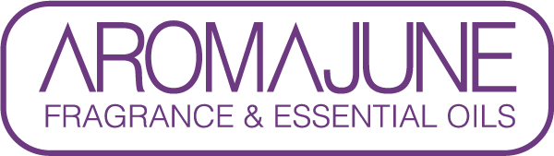

DATE : {{DATE}}
TO : {{CUSTOMER}}
SUBJCET : METHYL SALICYLATE CERTIFICATE
PRODUCT NAME : {{PRODUCT}}

AROMAJUNE, hereby certify that WATER SKIN RM does not contain methyl salicylate.



